Nama : Muhammad Atay Nadhif Nashrulloh NPM 18081010127

Github : https://github.com/Ataynadhif/PemrogramanWebA Tampilan Website

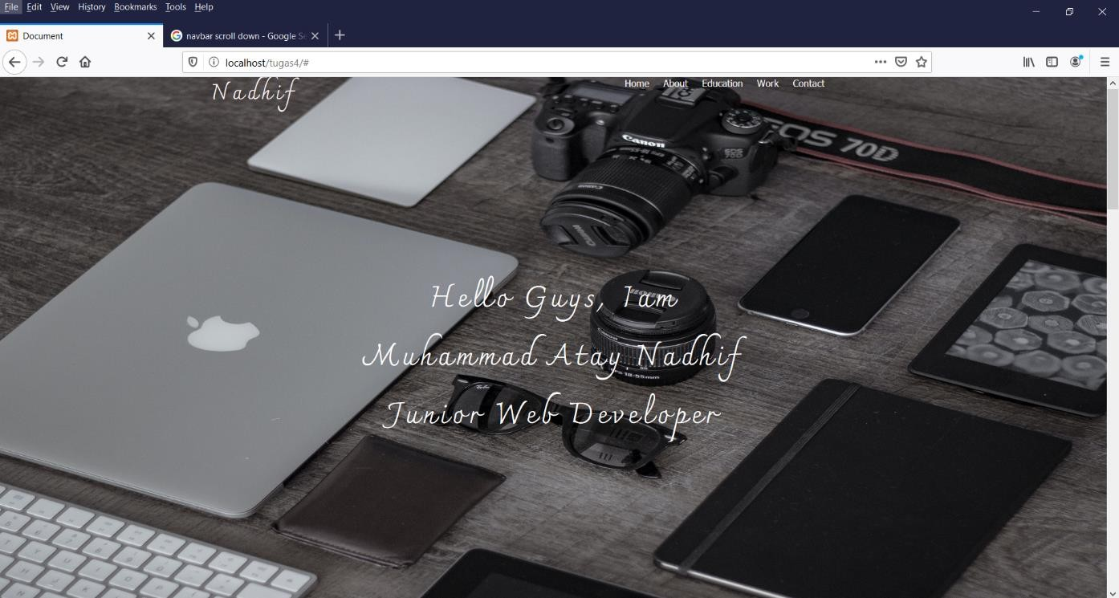

1. Home

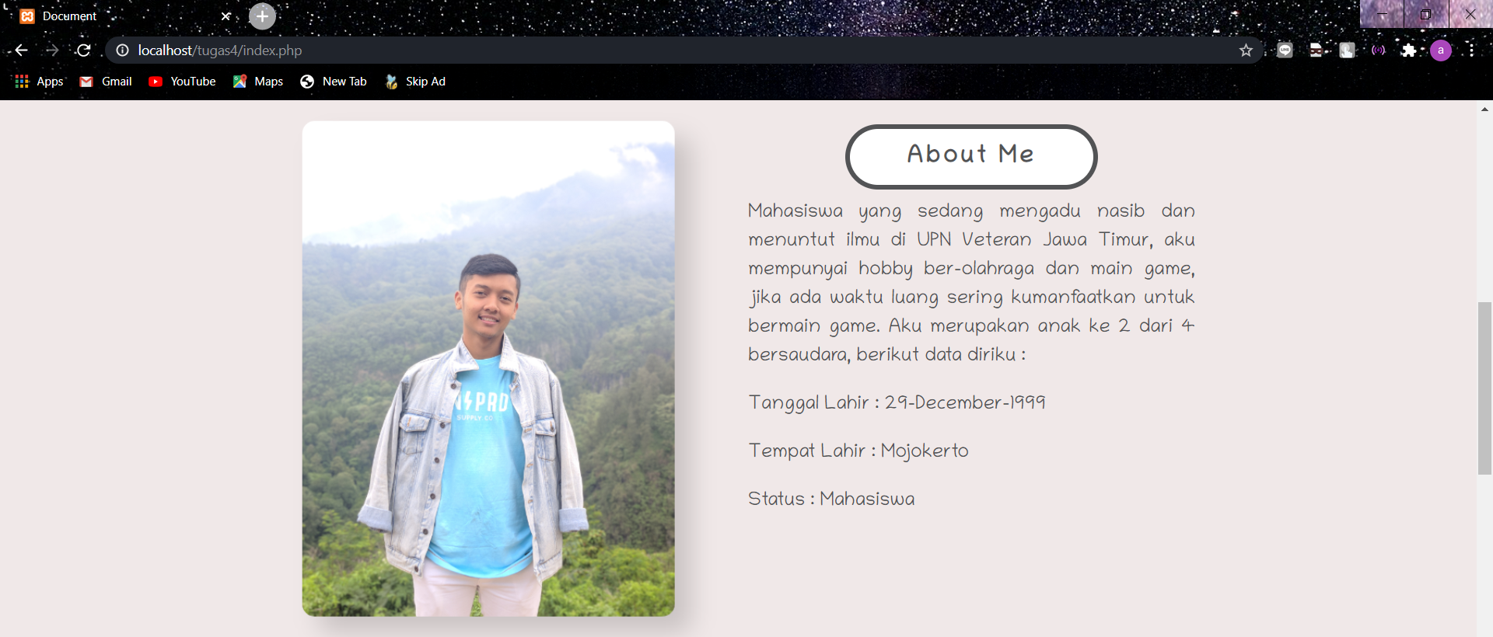

2.0 About

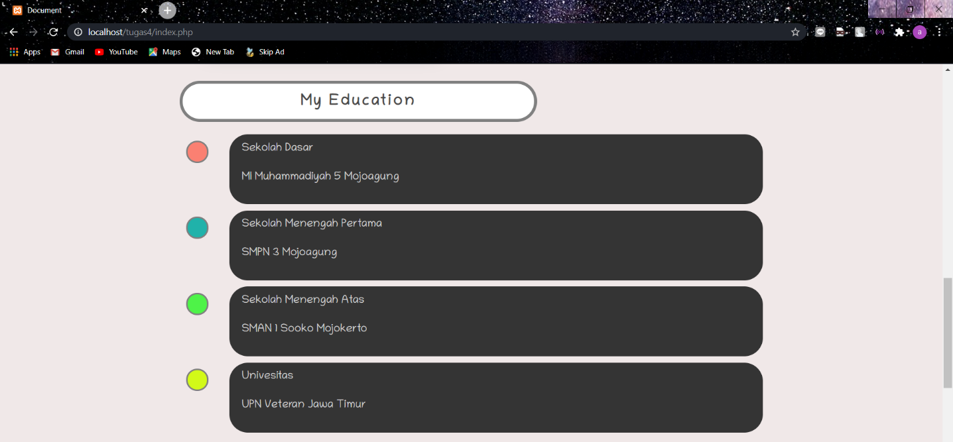

3.0 Education

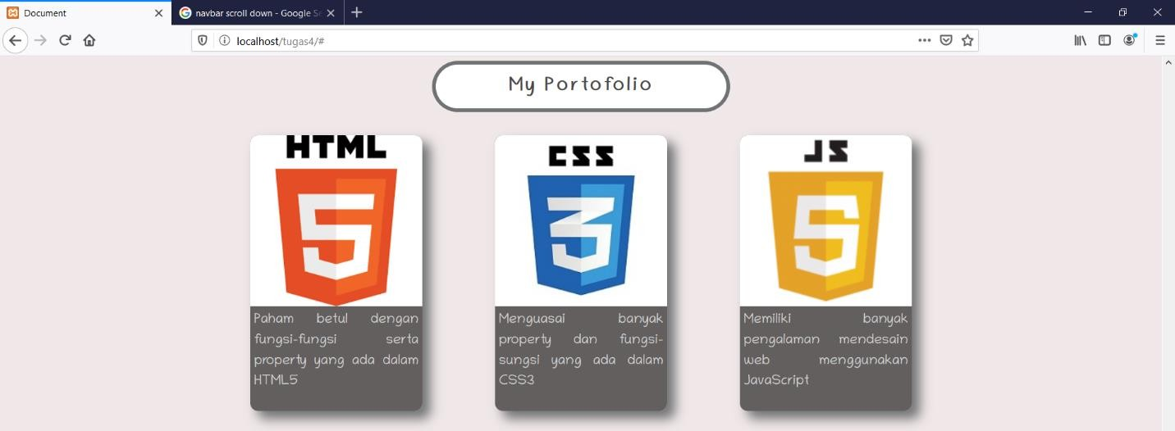

4.0 Skill

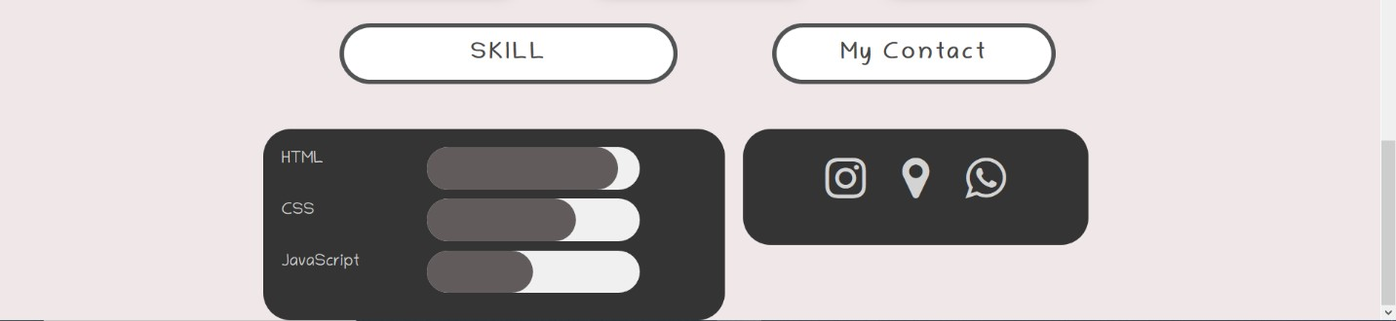

5.0 Contact

Data Base

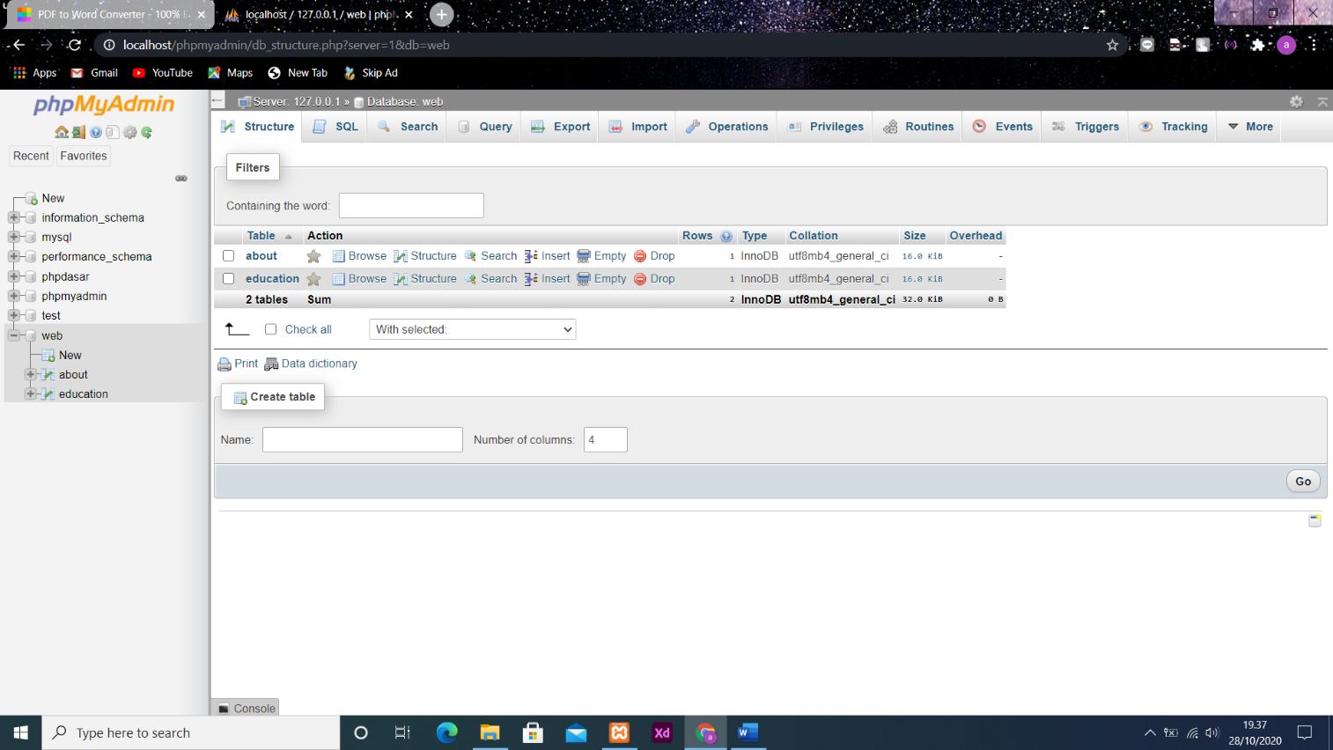

6.0 Database

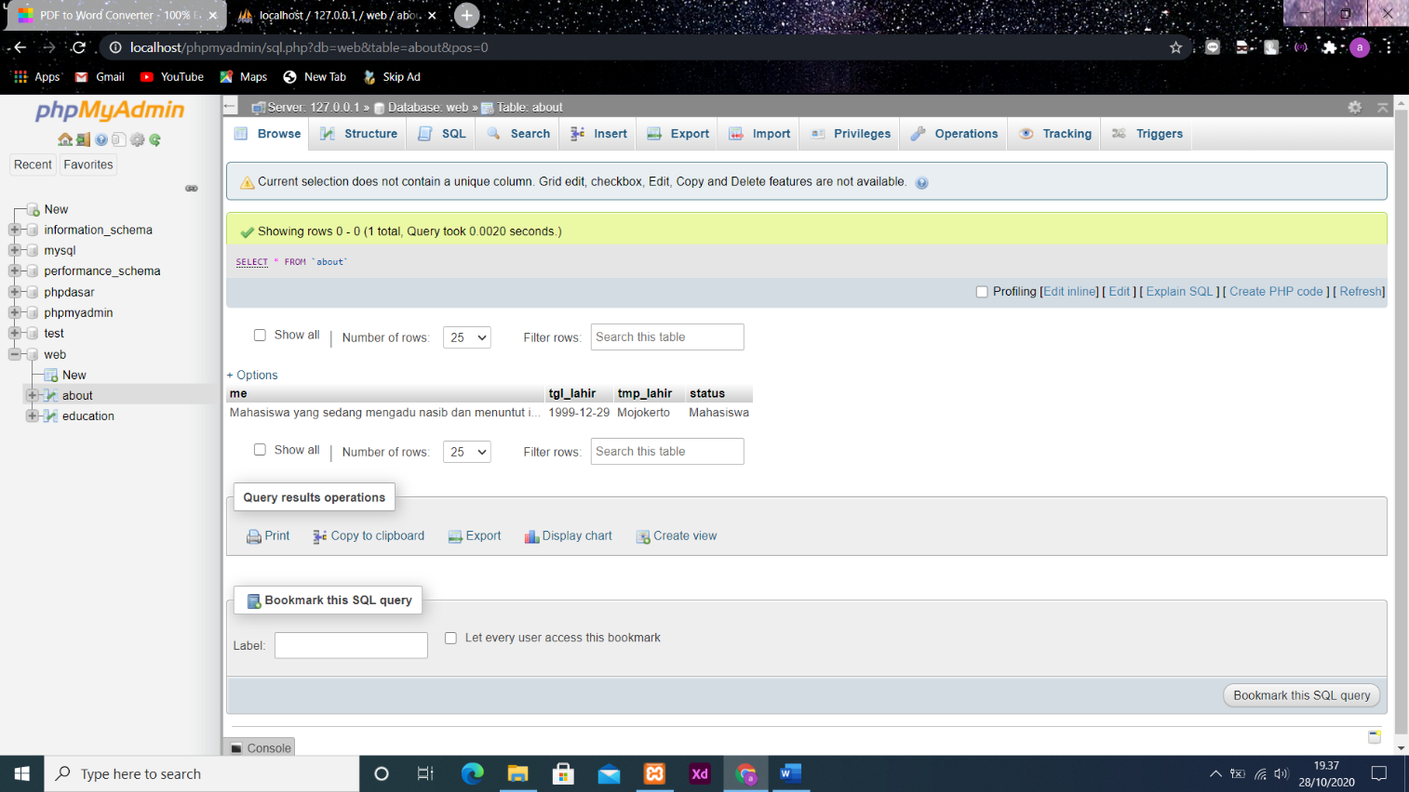

7.0 Table About

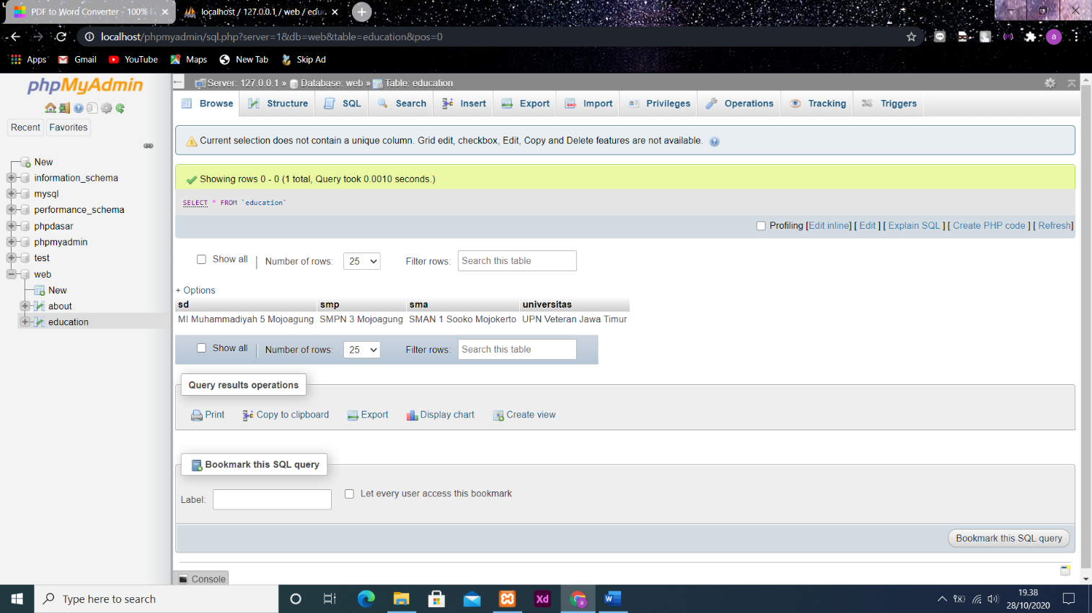

8.0 Table Education

Koneksi Database dengan php

|  |
| --- |
| <?php  // koneksi ke database  $conn = mysqli_connect("localhost", "root", "", "web");  function query($query)  {  global $conn;  $result = mysqli_query($conn, $query);  $rows = [];  while ($row = mysqli_fetch_assoc($result)) {  $rows[] = $row;  }  return $rows;  } |

conn.php

|  |
| --- |
| <?php  require 'conn.php';  $data = query("SELECT * FROM about");  $datas = query("SELECT * FROM education");  ?> |

Pemanggilan conn.php kedalam index.php

|  |
| --- |
| <?php foreach ($data as $row) : ?>  <div class="about">  <div class="grid_6">  <img src="img/profile.png">  </div>  <div class="grid_6">  <h1>About Me</h1>  <p><?php echo $row["me"]; ?></p>  <p>Tanggal Lahir : <?php echo date('d-F-Y', strtotime($row["tgl_lahir"])); ?></p>  <p>Tempat Lahir : <?php echo $row["tmp_lahir"]; ?></p>  <p>Status : <?php echo $row["status"]; ?></p>  </div>  </div>  <?php endforeach; ?>  <!-- ================== EDUCATION ================== -->  <?php foreach ($datas as $row) : ?>  <div class="grid_12 education">  <h1>My Education</h1>  </div>  <div class="grid_1">  <div class="item"></div>  </div>  <div class="grid_11 school">  <p>Sekolah Dasar</p>  <p><?php echo $row["sd"]; ?></p>  </div>  <div class="grid_1">  <div class="item2"></div>  </div>  <div class="grid_11 school">  <p>Sekolah Menengah Pertama</p>  <p><?php echo $row["smp"]; ?></p>  </div>  <div class="grid_1">  <div class="item3"></div>  </div>  <div class="grid_11 school">  <p>Sekolah Menengah Atas</p>  <p><?php echo $row["sma"]; ?></p>  </div>  <div class="grid_1">  <div class="item4"></div>  </div>  <div class="grid_11 school">  <p>Univesitas</p>  <p><?php echo $row["universitas"]; ?></p>  </div>  <?php endforeach; ?> |

Memanggil data dari database dan ditampilkan ke halaman web